Staff Equality networks Newsletter
The NHS Ombudsman Campaign
Across the NHS, too many staff are still facing racism, ableism and homophobia. When they speak up, they’re often silenced by the very systems meant to protect them.
Based on feedback from our network leaders, chairs and members, we have launched a national campaign calling for an NHS employment ombudsman, a truly independent body with legal powers to investigate, fine, and hold NHS leaders accountable when they fail to tackle discrimination and bullying.
According to the 2024 NHS staff survey:
- 9.8% of staff reported discrimination from a manager or colleague.
- 1 in 3 disabled staff say bullying or harassment is still routine.
This ombudsman would bring real accountability, reduce legal costs, and restore trust in the NHS workplace.
Support the campaign: Sign the petition here:
https://www.change.org/andi_changes_health
Together, we can build a safer, fairer NHS that works for everyone.

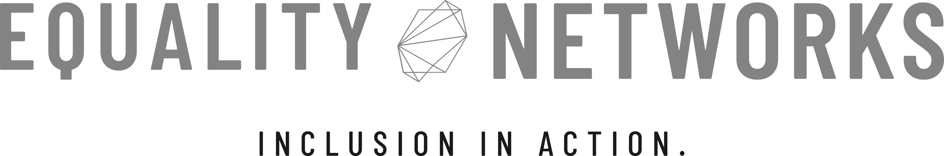

We are evolving! 
Good news, everyone! We’re thrilled to announce that Staff Equality Networks Ltd is entering a bold new chapter. After two successful years supporting Employee Resource Groups (ERGs) across the UK, we’re expanding our offer to include a full suite of Diversity, Equity, Inclusion and Belonging (DEIB) services.
Our new portfolio will include:
- Independent DEIB Audits to assess culture, policy, and practice.
- Equality Impact Assessment reviews to strengthen compliance and transparency.
- EDI Strategy Outsourcing, helping organisations design and deliver measurable inclusion plans.
- Bespoke training for leaders ready to embed change.
This expansion reflects our ongoing mission to help organisations move from awareness to accountability, and creating spaces where every identity is seen, valued, and respected.
To celebrate, we’re also launching a logo design competition! We’re looking for a fresh visual identity that captures the energy, vision, and intersectional spirit of our work. The winning design will feature across our new website, marketing, and branded materials.
Think bold. Think inclusive. Think transformation.
🎨 Staff Equality Networks Logo Design Competition – Now Open!
We’re inviting artists, designers, and creatives to shape the next chapter of Staff Equality Networks Ltd by creating a new logo that captures who we are and what we stand for.
🗓️ Competition Dates:
- Opens: 1st November 2025
- Closes: 1st December 2025 at 23:59 (UK time)
💡 Theme & Keywords:
Your design should reflect the spirit of our work and founder. Keywords: Black, Queer, Disabled, Feminine, Collaboration, and Intersectionality. We’re looking for something bold, meaningful, and rooted in belonging.
📬 How to Enter:
Submit your design as a high-resolution PNG or SVG file to andrea@staffequalitynetworks.co.uk with the subject line “Logo Competition Entry.”
Please include your full name, age, contact details, and a short paragraph (up to 250 words) explaining why you chose your design and how it connects to our theme.
⚖️ Rules for Entry:
- Open to UK residents aged 18 and over
- One entry per person
- All artwork must be original
🏆 Prize: The winner will receive £150 cash and official recognition across our website, press releases, and social media channels. The winner’s design will be across all of our new merchandise too.
Good luck! We cannot wait to see your vision of inclusive excellence!
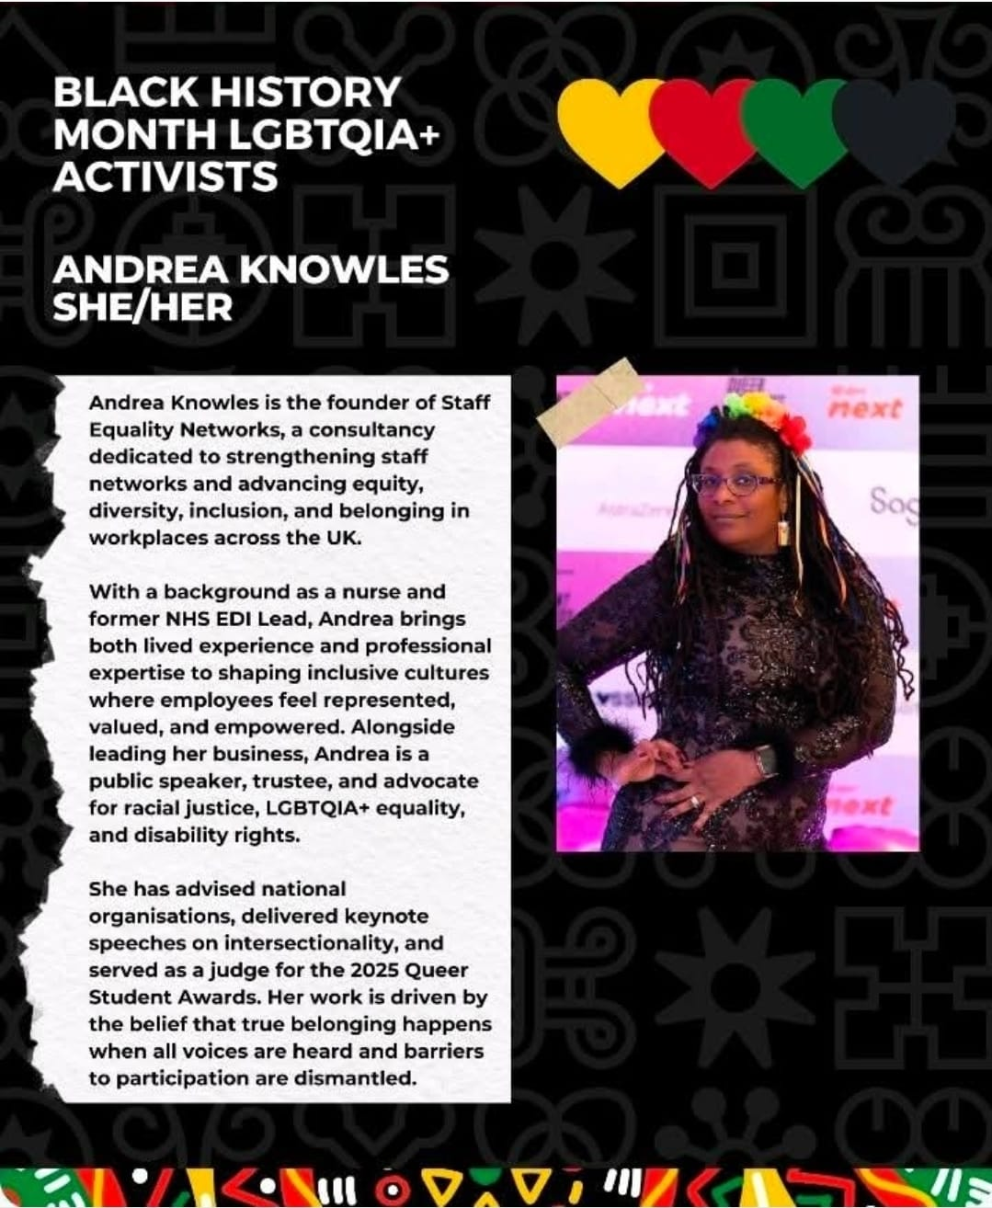

Thank you to the Consortium!
We’re proud to celebrate our Founder and Director, Andrea Knowles, for being recognised by the Consortium for LGBT+ as a Black History Month LGBTQIA+ Activist, a well-deserved recognition of her tireless advocacy for inclusion, visibility, and equity.
From nursing and NHS leadership to building one of the UK’s only Black, Disabled-led and LGBTQIA+ consultancies, Andrea continues to champion intersectional equality, ensuring that every voice, especially those most marginalised, is heard and valued.
Representation matters, but transformation matters more. I’m proud that Staff Equality Networks stands for both.”
— Andrea Knowles, Founder & Director
Consortium are a UK-based charity that supports not-for-profit LGBT+ organisations and groups.
Their goal is to help groups become stronger and more sustainable, so they can provide essential services and advocate for the rights of individuals in the community. Whether you are a long-standing group or just starting out, they are here to help you grow and succeed. They offer information and guidance on various topics, including management, finances, fundraising, and creating policy documents. Website: https://www.consortium.lgbt/

Reflections on black history month, 2025
This year’s Black History Month began on a heavy note. The BBC programme exposing the ongoing racism within the Metropolitan Police cast a long, painful shadow. It was difficult to watch and even more difficult to hear the tired, mocking question, “When is White History Month?” echoing across social media shortly after. It reminded me how far we still have to go in building empathy, understanding, and respect for lived experiences that fall outside the majority in the UK.
Add to this, the ridiculous roundabout painting, flag-waving fiasco that appeared in the pervailing months. It really took the shine off this year’s BHM celebrations for me and I declined speaking events.
However, the month wasn’t without its light. I had the honour of visiting the Houses of Parliament, a place steeped in history yet still in need of transformation. The energy, the love, and the collective sense of pride reminded me why I do this work why representation, equity, and visibility matter so deeply.
Back in the world of staff networks, the familiar challenge of funding reappeared. Too many network chairs are placed in roles of influence without the power or confidence to drive real change. Bound by organisational expectations, their creativity and impact are often stifled. That is when I LOVE to step in. Unbound by anything other than a sense of duty to support, I do adore the slow, glowing lightbulb, realisation that those who are affected can be heard and no-one is too small to take that first step.
I remain hopeful. Across the UK, I see passionate individuals quietly reshaping workplaces, sparking dialogue, and demanding better. Progress may be slow, but it’s steady and every voice raised in truth brings us closer to the inclusive future we deserve.
Andi

Network’s News
- Elena is a queer trainee psychologist completing their doctorate at the University of East London. They’ve dedicated their thesis to exploring how queer women relate to their identity after experiencing sexual harm intended to punish or ‘change’ their sexuality. They have are recruiting by sharing the study's flyer using various routes (social media, email, newsletters, WhatsApp) and we at Staff Equality Networks are sharing with you.
🌿Why? To amplify queer voices, advocate for affirming care, and contribute to systemic change.
💬 What? A 1 (one) hour confidential conversation, focused on identity, care, and resistance - no questions will ask about the event(s).
🌈 Who? Queer cis women (18+, UK-based). Future phases will centre other queer and trans experiences.
The study is ethics-approved. Participation is confidential, voluntary, and deeply appreciated.
💌Interested or want to know more? I’d love to hear from you. Email: u2631805@uel.ac.uk
Please share with anyone this may speak to 💛
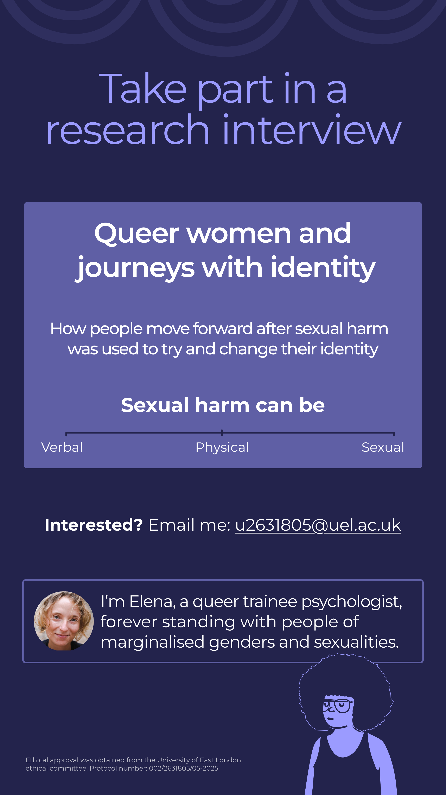
- A new nationwide study is shedding light on the lived experiences of Black professionals across the UK, with findings that strike a particularly powerful chord for those working in healthcare.
The research, which has already gathered insights from over 460 professionals, reveals stark realities that mirror the everyday challenges faced by many NHS staff:
- 91% feel they must work harder than colleagues to prove their competence
- 78% suppress aspects of their identity to progress professionally
- 65% report serious health impacts caused by workplace stress
These findings point to systemic barriers that may be fueling the NHS workforce retention crisis. It’s a painful irony that those dedicating their lives to caring for others are often working in environments that harm their own wellbeing.
We recognise how deeply this connects to our mission of empowering Employee Resource Groups (ERGs) to drive cultural change from within. Understanding these patterns helps us design stronger, data-led inclusion strategies that improve staff experience and retention.
📢 The research team is inviting healthcare professionals to take part in a 7-minute anonymous survey to strengthen the evidence base across the NHS.
👉 Take part here: https://forms.gle/Q5zVEraSdrh73GA2A
Every response helps to build a clearer picture — and a fairer future for our healthcare workforce.

Thank you!
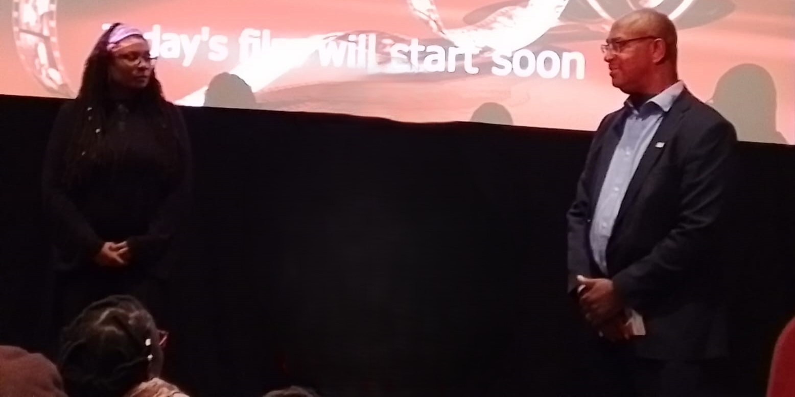
Andrea and Andrew at a BHM event
Contact Us
Staff Equality Networks
andrea@staffequalitynetworks.co.uk
Website: www.staffequalitynetworks.co.uk

Thank you for reading and for everything you do to build fairer, kinder workplaces. If this newsletter was useful, please share it with a colleague or community group, post it on your socials, and pass it on to your ERG leads. The more people who see it, the more impact we can make together. Got thoughts or wins to share? Hit reply; we’d love to hear from you.

